# Analysis of COVID19 in India

**As the coronavirus outbreak continues to spread in the country, the question that we as Indians are trying to answer is: whether India will be able to tackle its menace or are we going to witness another Italy or S.Korea**





# 

# 

# **Part 1: Analysing the present condition in India**

he first COVID-19 case was reported on 30 January during a student who arrived in Kerala state from Wuhan. Then 2 more cases were reported within the next 2 days in Kerala again. for pretty much a month, no new cases were reported in India, however, on 8th March, five new cases of coronavirus in Kerala were again reported and since then the cases are rising affecting 14 states, till now. Here could be a brief timeline of the primary 100 cases in India

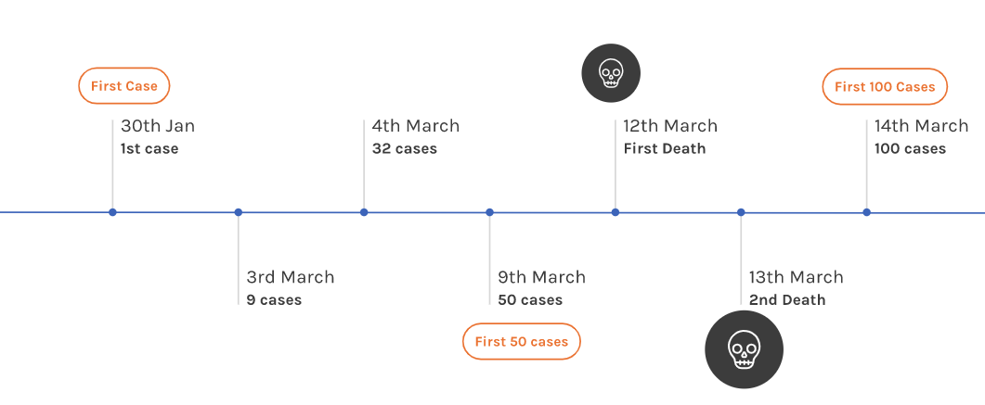

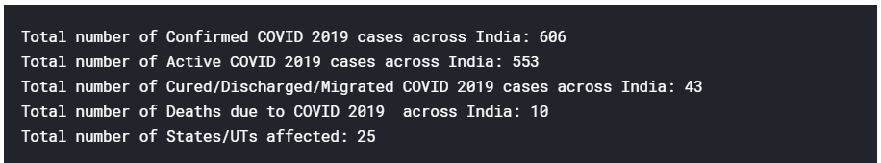

## 

## 

## 

## 

## 

## **1.1 Distribution of Cases all over the states**

Here in this table, we can find the States with the highest confirmed cases and also the highest cured/migrated/discharged cases**. Maharashtra** and **Kerala** are in a serious condition as per this table

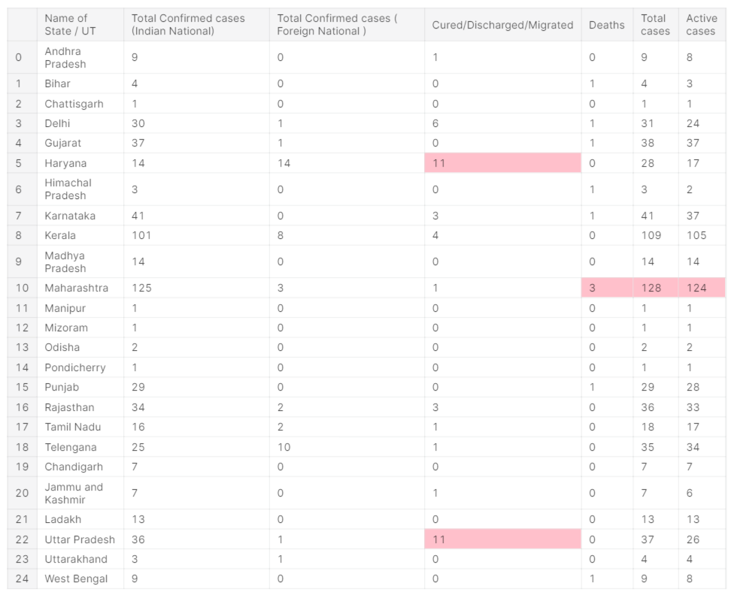

## **1.2 Comparing National and Foreign cases**

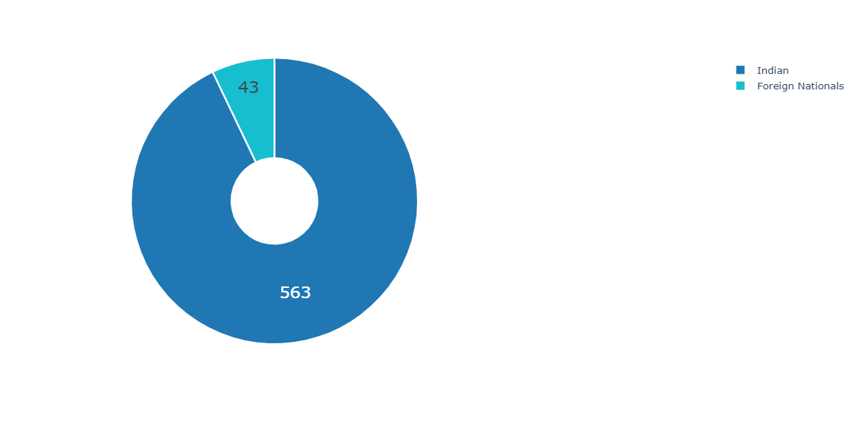

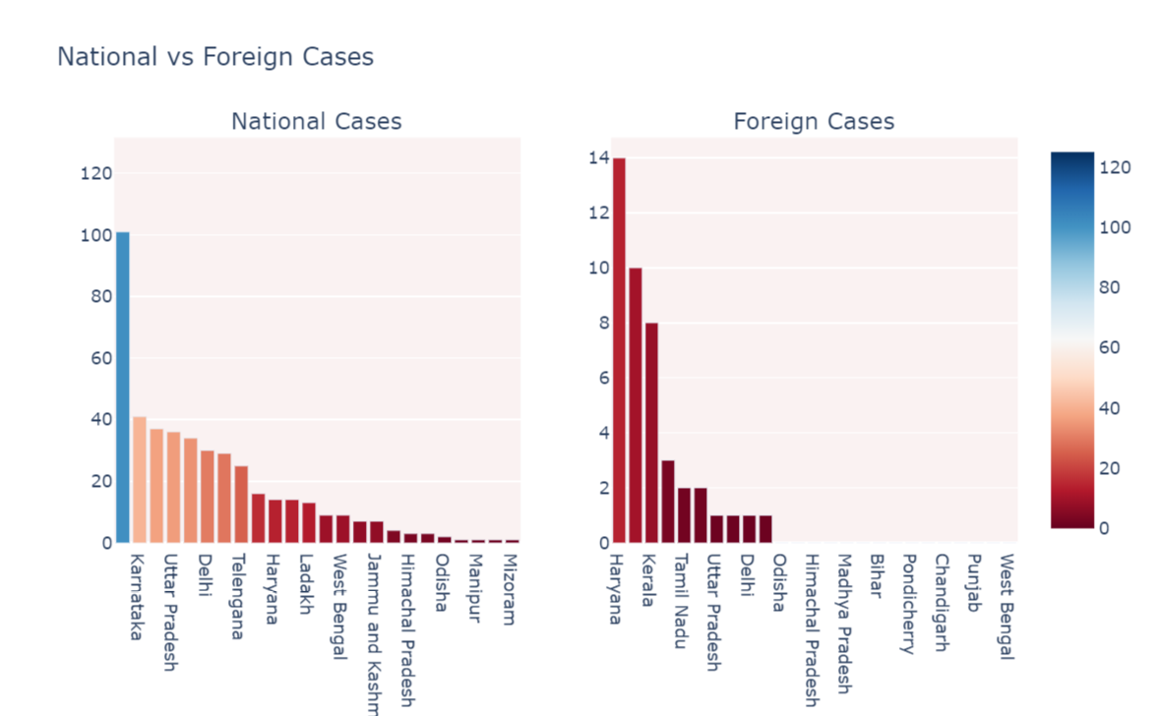

**The first case of the** [**2019–20 coronavirus pandemic**](https://en.wikipedia.org/wiki/2019%E2%80%9320_coronavirus_pandemic) **in** [**India**](https://en.wikipedia.org/wiki/India) **was reported on 30 January 2020, originating from** [**China**](https://en.wikipedia.org/wiki/2019%E2%80%9320_coronavirus_pandemic_in_Mainland_China)

Above analysis provides a clear view that COVID19 which was originated in China is spreading at its maximum extent, from the migrants from other countries it’s spreading to the local citizens

If we compare the **foreign cases(43)** and the **national cases(563)** there is a drastic change in the number, we can conclude that it’s spreading fastly all over the country **1.3 Geographical representation of State-wise Covid-19 cases**

## 

## 

## 

## 

## **1.4 Confirmed vs Recovered figures**

**Haryana** and **UP** are with highest rate of recovered cases in the country

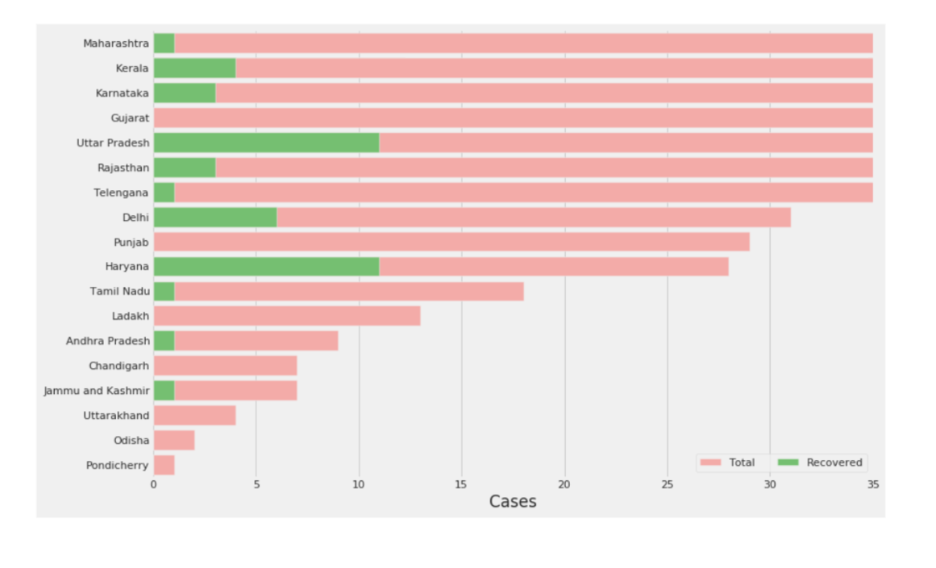

## 

# **2.1Comparing the situation of Italy and S.korea with India**

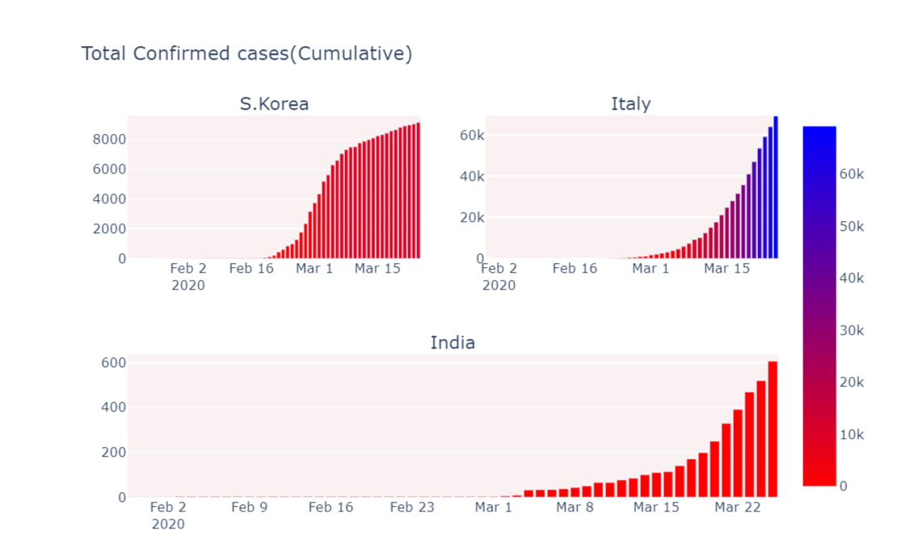

By , comparing the graphs we can find the trend of graph in I**ndia** is similar to **Italy**

## 

## **2.2 A Critical Insight showing the comparative trend and pattern of spread of COVID-19 in Italy and Korea with respect to India after Surpassing the Threshold of 100 Cases.**

**“By the analysis, we can say ‘Next Few Weeks Crucial’: India Will Either Contain COVID-19 Like China or go the Italy Way,**

**In the worst-case scenario, if India fails to manage the progression of the disease and goes the Italian way, one can expect more than 3,500 cases by April 15.”**

Name : MD ABDUL Razzaq

## 